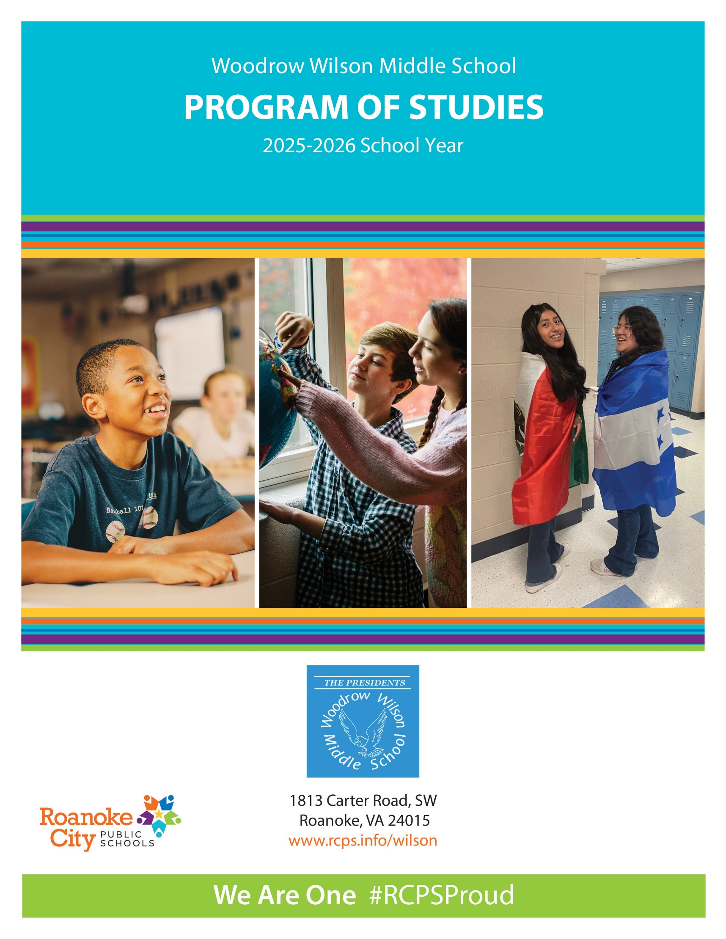

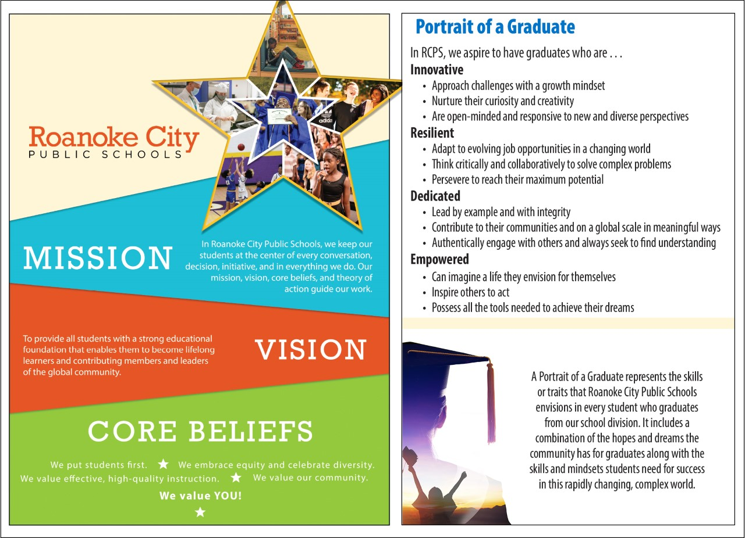

**ADMINISTRATION**

## Mr. Bradley Jenkins, Principal

Ms. Alisa Barnette, Assistant Principal

Mrs. Jacqualin Ibrahim, Assistant Principal

**SCHOOL COUNSELING DEPARTMENT**

Ms. Melissa Nelson, School Counseling Coordinator

## Ms. Claire Dobson, School Counselor

## Ms. Anna Schnetzler, School Counselor

**INTRODUCTION**

The following program of studies contains all courses that will be offered at Woodrow Wilson Middle School during the 2025-2026 school year. All courses are year-long (2 semesters) unless specifically noted. Middle school students must take a full schedule of courses.

**COURSE SELECTION**

Middle school students in grades 6-8 must select (7) courses in the following subject areas each year:

* English
* Mathematics
* Science
* Social Studies
* Physical Education
* Electives (2)

Every effort is made to enroll students in their first choice of elective. Each middle school student will have the opportunity to participate in multiple electives or a combination of remediation (extra help) and electives each year. Students should select their top three choices for electives in case one of their top two choices is unavailable.

**MIDDLE SCHOOL COURSE DESCRIPTIONS**

**ENGLISH**

### 6th Grade Courses

**1109 English 6**

This course emphasizes communication skills, multimodal presentations, and interpreting media messages. It builds on vocabulary, introduces word origins, strengthens reading comprehension, compares fiction to non-fiction works, and teaches creation of objective summaries. Students will practice the writing process and craft thesis statements with a focus on narrative and reflective writing. Research skills are introduced. Students will take the English 6 SOL assessment.

**1109H Advanced English 6**

This course develops the skills, thought processes, and concepts that will facilitate success in high school Advanced Placement English courses. It emphasizes communication skills, multimodal presentations, and interpreting media messages. Students think critically about vocabulary, word origins, text analysis and comparison, and objective summaries. Students will utilize the writing process, thesis statements, and write regularly with a focus on narrative and reflective writing. Research skills are introduced and practiced. Students will take the English 6 SOL assessment. Prerequisite: Teacher or department recommendation

### 7th Grade Courses

**1110 English 7**

This course emphasizes communication skills through individual and group discussions, presentations, and examination of media techniques. It continues building vocabulary, emphasizes reading comprehension, focuses on author’s style, compares fiction and non-fiction texts, identifies source, purpose, and point of view of texts. Students develop writing with an emphasis on expository and persuasive forms and develop foundational research skills. Students will take the English 7 SOL assessment.

**1110H Advanced English 7**

This course develops the skills, thought processes, and concepts that will facilitate success in high school Advanced Placement English courses. It emphasizes communication skills through individual and group discussions, presentations, and examination of media techniques. It emphasizes vocabulary, reading comprehension and analysis, text comparison, and critical thinking. Students develop as writers, strengthen control of conventions, write primarily in expository and persuasive forms, and build on foundational research skills. Students will take the English 7 SOL assessment. Prerequisite: Teacher or department recommendation

### 8th Grade Courses

**1120 English 8**

This course emphasizes communication skills through individual and group discussions, presentations, and evaluation of media messages. It continues building vocabulary, emphasizes reading comprehension, focuses on theme and comparing authors’ styles, compares fiction and non-fiction texts, and analyzes author’s qualifications. Students continue to develop writing skills with an emphasis on expository and persuasive forms, utilize claims and evidence as support, and apply research skills. Students will take the English 8 SOL assessment.

**1120H Advanced English 8**

This course develops the skills, thought processes, and concepts that will facilitate success in high school Advanced Placement English courses. It emphasizes communication skills through individual and group discussions, presentations, and evaluation of media messages. It emphasizes critical thinking through analysis and evaluation of a variety of genres. Students build vocabulary, analyze authors’ styles and qualifications, and compare texts. Students develop as writers, exhibit control of writing conventions, write in expository and persuasive forms, incorporate claims, and evidence as support, and apply research skills. Students will take the English 8 SOL assessment. Prerequisite: Teacher or department recommendation

**MATHEMATICS**

### 6th Grade Courses

**3110 Mathematics 6**

The *Standards* for this course include a focus on single-step and multistep problems involving operations with integers and positive rational numbers. Students will determine equivalency, compare, and order decimals, fractions, and percents. Students will solve problems involving area and perimeter and begin to graph in a coordinate plane. In addition, students will continue using the data cycle by applying it to circle graphs and develop concepts regarding measures of center. Students will solve linear equations in one variable, write inequality statements, and use algebraic terminology. Students will use ratios to compare two quantities and represent proportional relationships as a precursor to the development of the concept of linear functions. Students will take the Mathematics 6 SOL assessment.

**3110H Advanced Mathematics 6**

The *Standards* for this course include a focus on single-step and multistep problems involving operations with integers and positive rational numbers. Students will determine equivalency, compare, and order decimals, fractions, and percents. Students will solve problems involving area and perimeter and begin to graph in a coordinate plane. In addition, students will continue using the data cycle by applying it to circle graphs and develop concepts regarding measures of center. Students will solve linear equations in one variable, write inequality statements, and use algebraic terminology. Students will use ratios to compare two quantities and represent proportional relationships as a precursor to the development of the concept of linear functions.

In addition to the topics in the Mathematics 6 curriculum, students will explore additional concepts from Mathematics 7. These concepts include, but are not limited to, solving two-step equations and inequalities, understanding slope as a rate of change, and applying proportional reasoning to solve practical problems. Students will take the Mathematics 6 SOL assessment. Prerequisite: Teacher or department recommendation

\***Students interested in applying to Roanoke Valley Governor’s School in 9th grade should enroll in this course to stay on track for RVGS enrollment.**

### 7th Grade Courses

**3111 Mathematics 7**

The *Standards* for this courseaddress the representation and comparison of rational numbers using exponents, scientific notation, and square roots. Students continue to develop proficiency in operations with rational numbers and solving problems in context by expanding their study from Grade 6. Students will build on the concept of ratios to solve problems involving proportional reasoning*.* Students will solve problems involving volume and surface area and focus on the relationships among the properties of quadrilaterals. In addition, students will continue to apply the data cycle and extend the application to histograms. Probability is investigated by comparing experimental results to theoretical expectations. Students continue to develop their understanding of solving linear equations and inequalities in one variable by applying the properties of real numbers. Students investigate proportional relationships and begin to develop a concept of slope as rate of change. Students will take the Mathematics 7 SOL assessment.

**3111H Advanced Mathematics 7**

The *Standards* for this courseaddress the representation and comparison of rational numbers using exponents, scientific notation, and square roots. Students continue to develop proficiency in operations with rational numbers and solving problems in context by expanding their study from Grade 6. Students will build on the concept of ratios to solve problems involving proportional reasoning*.* Students will solve problems involving volume and surface area and focus on the relationships among the properties of quadrilaterals. In addition, students will continue to apply the data cycle and extend the application to histograms. Probability is investigated by comparing experimental results to theoretical expectations. Students continue to develop their understanding of solving linear equations and inequalities in one variable by applying the properties of real numbers. Students investigate proportional relationships and begin to develop a concept of slope as rate of change.

In addition to the topics in the Mathematics 7 curriculum, students will explore additional concepts from Mathematics 8. These concepts include, but are not limited to, solving multi-step equations and inequalities, understanding the graph of a linear function of the form y = mx + b, and evaluating/simplifying expressions for given replacement values. Additional geometry concepts may include angle relationships and exploring the Pythagorean Theorem. Students will take the Mathematics 7 SOL assessment. Prerequisite: Teacher or department recommendation

### 3130 Algebra I (1 credit)

The study of Algebra I assists students in generalizing patterns and representing relevant, contextual situations with algebraic models. The *Standards* require students to use algebra as a tool for representing and solving a variety of contextual problems. Tables and graphs will be used to interpret algebraic expressions, equations, and inequalities and to analyze behaviors of functions. These Standards include a transformational approach to graphing functions and writing equations when given the graph of the equation. Transformational graphing builds a strong connection between algebraic and graphic representations of functions. Technology tools will be used to assist in teaching and learning. Students will take the Mathematics Algebra I SOL assessment.

**\*Students interested in applying to Roanoke Valley Governor’s School in 9th grade should enroll in this course to stay on track for RVGS enrollment.**

### 8th Grade Courses

**3112 Mathematics 8**

The *Standards* for this course explore real numbers and the subsets of the real number system. Proportional reasoning is expounded upon as students solve a variety of problems. Students find the volume and surface area of complex three-dimensional figures and apply transformations to geometric shapes in the coordinate plane. Students will verify and apply the Pythagorean Theorem creating a foundation for further study of triangular relationships in Geometry. Students will represent data, both univariate and bivariate, and continue to apply the data cycle and extend the application to boxplots and scatterplots. Students will take the Mathematics 8 SOL assessment.

### 3130 Algebra I (1 Credit)

The study of Algebra I assists students in generalizing patterns and representing relevant, contextual situations with algebraic models. The *Standards* require students to use algebra as a tool for representing and solving a variety of contextual problems. Tables and graphs will be used to interpret algebraic expressions, equations, and inequalities and to analyze behaviors of functions. These Standards include a transformational approach to graphing functions and writing equations when given the graph of the equation. Transformational graphing builds a strong connection between algebraic and graphic representations of functions. Technology tools will be used to assist in teaching and learning. Students will take the Mathematics Algebra I SOL assessment.

### 3143 Geometry (1 credit)

The course includes an emphasis on developing reasoning skills through the exploration of geometric relationships including properties of geometric figures, trigonometric relationships, and mathematical proofs. In this course, students use various types of reasoning, justification, and methods of direct and indirect proof and interpret and determine the validity of conditional statements. The *Standards* emphasize two- and three-dimensional reasoning skills, coordinate and transformational geometry, and the use of geometric models to solve problems. Technology tools and dynamic geometry applications will be used to assist in teaching and learning. Students will take the Mathematics Geometry SOL assessment.

**\*Students interested in applying to Roanoke Valley Governor’s School in 9th grade should enroll in this course to stay on track for RVGS enrollment.**

**SCIENCE**

### 6th Grade Courses

**4105 Science 6**

The standards for sixth grade science investigate the concept of Our World, Our Responsibility. Topics include our place in the solar system and the interactions of water, energy, air, and ecosystems on the Earth. Content from this course is assessed on the Science 8 SOL assessment.

**4115H Advanced Life Science 6**

The Life Science standards emphasize a more complex understanding of change, cycles, patterns, and relationships in the living world. Students build on basic principles related to these concepts by exploring the cellular organization and the classification of organisms; the dynamic relationships among organisms, populations, communities, and ecosystems; and change as a result of the transmission of genetic information from generation to generation. Students build on their scientific investigation skills through a required science fair project. Content from this course is assessed on the Science 8 SOL assessment. Prerequisite: Teacher or department recommendation

**\*Students interested in applying to Roanoke Valley Governor’s School in 9th grade should enroll in this course to stay on track for RVGS enrollment.**

### 7th Grade Courses

**4115 Life Science 7**

The Life Science standards emphasize a more complex understanding of change, cycles, patterns, and relationships in the living world. Students build on basic principles related to these concepts by exploring the cellular organization and the classification of organisms; the dynamic relationships among organisms, populations, communities, and ecosystems; and change as a result of the transmission of genetic information from generation to generation. Students build on their scientific investigation skills through more independent identification of questions and planning of investigations. Content from this course is assessed on the Science 8 SOL assessment.

Prerequisite: Science 6

**4125H Advanced Physical Science 7**

The Physical Science standards stress an in-depth understanding of the nature and structure of matter and the characteristics of energy. Major areas covered by the standards include the particle nature of matter, the organization and use of the periodic table; physical and chemical changes; energy transfer and transformations; properties of longitudinal and transverse waves; electricity and magnetism; and work, force, and motion. The standards continue to build on skills of systematic investigation with a clear focus on variables and repeated trials. Students are required to complete a science fair project. Students will take the Science 8 SOL assessment. Prerequisite: Advanced Life Science 6

### 8th Grade Courses

**4125 Physical Science 8**

The Physical Science standards stress an in-depth understanding of the nature and structure of matter and the characteristics of energy. Major areas covered by the standards include the particle nature of matter, the organization and use of the periodic table; physical and chemical changes; energy transfer and transformations; properties of longitudinal and transverse waves; electricity and magnetism; and work, force, and motion. The standards continue to build on skills of systematic investigation with a clear focus on variables and repeated trials. Validating conclusions using evidence and data becomes increasingly important at this level. Mathematics and computational thinking gain importance as students advance in their scientific thinking. Required Science 8 SOL assessment. Prerequisite: Life Science 7

**4210 Earth Science**

The Earth Science standards focus on the complex nature of the Earth system, including Earth’s composition, structure, processes, and history; its atmosphere, fresh water, and oceans; and its environment in space as a set of complex, interacting and overlapping systems. The standards emphasize historical contributions in the development of scientific thought about Earth and space. The standards stress the interpretation of maps, charts, tables, and profiles; the use of technology to collect, analyze, and report data; and the utilization of science skills in systematic investigation. Problem solving and decision-making are an integral part of the standards, especially as they relate to the costs and benefits of utilizing Earth’s resources. Mathematics and computational thinking are important as students advance in their scientific thinking. Students will take the Earth Science SOL assessment. Students will earn one high school credit for this course. Prerequisite: Advanced Physical Science 7

**SOCIAL STUDIES**

### 6th Grade Courses

**46103 US History I**

Students will use skills for historical and geographical analysis to explore the early history of the United States and understand ideas and events that strengthened the union. The standards for this course relate to the history of the United States from pre-Columbian times until 1865. Students will continue to learn fundamental concepts in civics, economics, and geography as they study United States history in chronological sequence and learn about change and continuity in our history. They also will study documents and speeches that laid the foundation for American ideals and institutions and will examine the everyday life of people at different times in the country’s history through the use of primary and secondary sources.

**46103H Advanced US History I and II**

Students will develop and use advanced skills for historical and geographical analysis to explore the early history of the United States and understand ideas and events that strengthened the union. The standards for this course relate to the history of the United States from pre-Columbian times to the present. Students will continue to learn fundamental concepts in civics, economics, and geography as they study United States history in chronological sequence and learn about change and continuity in our history. Political, economic, and social challenges facing the nation reunited after the Civil War will be examined chronologically as students develop an understanding of how the American experience shaped the world’s political and economic landscapes. They also will study documents and speeches that laid the foundation for American ideals and institutions and will examine the everyday life of people at different times in the country’s history through the analysis and synthesis of primary and secondary sources through writing and oral presentations. Prerequisite: Teacher or department recommendation

### 7th Grade Courses

**47103 US History II**

Students will examine American history since 1865. The standards for this course relate to the history of the United States from the Reconstruction era to the present. Students will continue to learn fundamental concepts in civics, economics, and geography within the context of United States history. Political, economic, and social challenges facing the nation reunited after the Civil War will be examined chronologically as students develop an understanding of how the American experience shaped the world’s political and economic landscapes.

**48103H Advanced Civics and Economics 7**

Students will examine the roles citizens play in the political, governmental, and economic systems in the United States and make connections to modern day civic life. Students will examine the constitutions of Virginia and the United States, will identify the rights, duties, and responsibilities of citizens, and will describe the structure and operation of government at the local, state, and national levels. Students will investigate the process by which decisions are made in the American market economy and explain the government’s role in it. The standards identify personal character traits, such as patriotism, respect for the law, willingness to perform public service, and a sense of civic duty, that facilitate thoughtful and effective active participation in the civic life of an increasingly diverse democratic society.  Students will analyze and synthesize primary and secondary sources through writing and oral presentations. Students will take the Civics SOL assessment. Prerequisite: Teacher or department recommendation

### 8th Grade Courses

**48103 Civics and Economics**

Students will examine the roles citizens play in the political, governmental, and economic systems in the United States. Students will examine the constitutions of Virginia and the United States, will identify the rights, duties, and responsibilities of citizens, and will describe the structure and operation of government at the local, state, and national levels. Students will investigate the process by which decisions are made in the American market economy and explain the government’s role in it. The standards identify personal character traits, such as patriotism, respect for the law, willingness to perform public service, and a sense of civic duty, that facilitate thoughtful and effective active participation in the civic life of an increasingly diverse democratic society. Students will take the Civics SOL assessment.

**48103H Advanced Civics and Economics 8**

Students will examine the roles citizens play in the political, governmental, and economic systems in the United States and make connections to modern day civic life. Students will examine the constitutions of Virginia and the United States, will identify the rights, duties, and responsibilities of citizens, and will describe the structure and operation of government at the local, state, and national levels. Students will investigate the process by which decisions are made in the American market economy and explain the government’s role in it. The standards identify personal character traits, such as patriotism, respect for the law, willingness to perform public service, and a sense of civic duty, that facilitate thoughtful and effective active participation in the civic life of an increasingly diverse democratic society.  Students will analyze and synthesize primary and secondary sources through writing and oral presentations. Students will take the Civics SOL assessment. Prerequisite: Teacher or department recommendation

**HEALTH & PHYSICAL EDUCATION**

**760 Health and Physical Education - Grade 6**

Students will combine fundamental skills into more complex movement forms in units such as physical fitness and conditioning, rhythmic activities, gymnastics, soccer, basketball, softball, and volleyball. Students will begin to experience recreational activities such as skating and bowling. Students will assess their health-related fitness status and set reasonable and appropriate goals for development and improvement. Students will understand health issues and the relationship between choices and consequences. Health learning outcomes include topics on body systems, nutrition, physical health, disease prevention, substance misuse prevention, safety and injury prevention, mental wellness, violence prevention, community and environmental health, and family life.

**770 Health and Physical Education - Grade 7**

Students will continue to develop competence in modified versions of game/sport, dance, and recreational activities. Instruction will include physical fitness, flag football, bowling, soccer, rhythms, basketball, volleyball, tennis, golf, weight training, softball, and recreational pursuits. The student will analyze skill performance and set reasonable and appropriate goals for improvement and maintenance of health-related fitness. Health learning outcomes include topics on body systems, nutrition, physical health, disease prevention, substance misuse prevention, safety and injury prevention, mental wellness, violence prevention, community and environmental health, and family life.

**780 Health and Physical Education - Grade 8**

Students will begin to demonstrate competence in skillful movement in modified, dynamic game/sport activities and in a variety of rhythmic and recreational activities. Instruction in physical education includes physical fitness, soccer, basketball, tennis, bowling, volleyball, weight training, softball, and recreational pursuits. Recreational pursuits may include skating, orienteering, cycling, ropes courses, backpacking, hiking, canoeing, and/or rock climbing. Students will set goals, track progress, and participate in activities to improve lifetime health-related fitness. Health learning outcomes include topics on body systems, nutrition, physical health, disease prevention, substance misuse prevention, safety and injury prevention, mental wellness, violence prevention, community and environmental health, and family life.

**ELECTIVES**

**6th Grade Exploratory Rotation**

**Rotation 1**

**66104 Art 6**

This class is an introductory 9-week visual art course which focuses on the elements of art and design. Students will explore a variety of art media and techniques as well as creating original works of art.

**56102 Language Exploratory**

Students learn about world languages and cultures.  Activities include food tasting, music, and making cultural comparisons.

**3999-6 STEAM/Career Invest**

This 9-week exploratory learning course engages students with hands on and collaborative learning to build knowledge and skills in science, technology, engineering, art, and math helping students investigate and discover solutions to real world problems.

**9213 General Music**

In this course, students will be exposed to different types of music from 1700’s – Present Day. Students will learn what instruments were used when the music was written and how the world affected the written music.

**Rotation 2**

**R6609-9 Computer Solutions**

Learn about introductory information about online security, computer viruses, current technology systems, spreadsheets, documents, input data formulas, graphs, charts, database, worldwide network communication systems and coding. This is an elective 9-week course.

**Digital Art**

Students learn art theory concepts such as the elements of art, principles of design, composition and color theory.  Using websites that support digital drawing/painting, students learn the tools necessary to apply art theory concepts on a digital platform.

**R6150-9 Keyboarding 6**

This course is designed for each student to become more comfortable using their keyboard to input information when using computers. Students will learn the correct hand positioning, basic computer terminology and get the repetitive practice that will result in typing faster and more accurately.

**9222 Music Appreciation**

In this course, students will be exposed to different types of music from 1700’s – Present Day. Students will learn what instruments were used when the music was written and how the world affected the written music.

**Career and Technical Education Electives (CTE)**

**7th Grade Electives**

**R9069 Career Investigations**

This is an elective 18-week course that focuses on the exploration of career options for the student.  The student uses a variety of personality inventory assessment tools and learning style assessment tools.  The student then utilizes these tools to complete a comprehensive study of three possible career choices they are interested in exploring.  Then the course proceeds to the path to undertake these possible careers in their education journeys. (18 weeks)

**R6609-18 Computer Solutions**

Learn about introductory information about online security, computer viruses, current technology systems, spreadsheets, documents, input data formulas, graphs, charts, database, worldwide network communication systems and coding. (18 weeks)

**R6150-18 Keyboarding**

This 18-week course is designed for each student to become more comfortable using their keyboard to input information when using computers. Students will continue using the correct hand positioning and get advanced experience with repetitive practice that will result in typing more efficiently. (18 weeks)

**8th Grade Electives**

**R6160 Digital Tech**

This is an elective 18-week course that focuses on the exploration of career options for the student.  The student uses a variety of personality inventory assessment tools and learning style assessment tools.  The student then utilizes these tools to complete a comprehensive study of three possible career choices they are interested in exploring.  Then the course proceeds to the path to undertake these possible careers in their education journeys.

**Fine Arts Electives**

**6th Grade Electives**

**66103 Band 6**

This course is designed for 6th graders with no band instrument experience and for those who participated in the elementary VH1 programs. The purpose of this course is to develop instrumental techniques and musical knowledge through ensemble rehearsals, individual practice and listening activities. Students will show progress in reading and playing a variety of rhythms, notes, articulations, dynamics, and musical styles while demonstrating the necessary discipline and preparedness for participating in class and performing in a large group setting. The middle school orchestra program serves as a creative community for all students who wish to participate, while at the same time serving the music department, the school, and community through seasonal concerts and community performances.

**66102 Strings 6**

This course is designed for 6th graders with no string instrument experience and for those who participated in the elementary VH1 programs. The purpose of this course is to develop instrumental techniques and musical knowledge through ensemble rehearsals, individual practice, and listening activities. Students will show progress in reading and playing a variety of rhythms, notes, bowing articulations, dynamics, and musical styles while demonstrating the necessary discipline and preparedness for participating in class and performing in a large group setting. The middle school orchestra program serves as a creative community for all students who wish to participate, while at the same time serving the music department, the school, and community through seasonal concerts and community performances. No previous experience needed!

**7th Grade Electives**

**67104 Art 7**

Students will continue to practice and expand their knowledge of the elements and principles of art. Students will create personally directed artworks using a variety of materials, mediums and techniques. Students will study artists and art history as they relate to the project.

**9197 Digital Art**

Art History is a digital art class where, in addition to learning about art theory concepts, students also study objects of art from the past and its relationship to art in present time. (18 weeks)

**67103 Band 7**

This course is designed for 7th graders who participated in band at their middle school throughout 6th grade. The purpose of this course is to further develop instrumental techniques and musical knowledge through ensemble rehearsals, individual practice, and listening activities. Students will continue to show progress in reading and playing a variety of rhythms, notes, articulations, dynamics, and musical styles while demonstrating the necessary discipline and preparedness for participating in class and performing in a large group setting. The middle school orchestra program serves as a creative community for all students who wish to participate, while at the same time serving the music department, the school, and community through seasonal concerts, community performances, and VBODA Concert Assessment.

**9270 Choir 7**

Students will learn to sing in a group through a variety of music genres including classical, pop, jazz, and musical theater.  You will also learn to read music and use music to express yourself. Singing in class daily and concerts after school are required for this course.

**67102 Strings 7**

This course is designed for 7th graders who participated in strings at their middle school throughout 6th grade. The purpose of this course is to further develop instrumental techniques and musical knowledge through ensemble rehearsals, individual practice, and listening activities. Students will continue to show progress in reading and playing a variety of rhythms, notes, bowing articulations, dynamics, and musical styles while demonstrating the necessary discipline and preparedness for participating in class and performing in a large group setting. The middle school orchestra program serves as a creative community for all students who wish to participate, while at the same time serving the music department, the school, and community through seasonal concerts, community performances, and VBODA Concert Assessment.

**8th Grade Electives**

**68104 Art 8**

In this course students will gain a comprehensive art experience through the production of art through a variety of art media and techniques. In addition to art production, students will increase their understanding of art history through discussions and observations.

**68103 Band 8**

This course is designed for 8th graders who participated in band at their middle school throughout 6th grade and 7th grade. The purpose of this course is to further develop instrumental techniques and musical knowledge in preparation for participation in high school band. This is accomplished through ensemble rehearsals, individual practice, and listening activities. Students will continue to show progress in reading and playing a variety of rhythms, notes, articulations, dynamics, and musical styles while demonstrating the necessary discipline and preparedness for participating in class and performing in a large group setting. The middle school orchestra program serves as a creative community for all students who wish to participate, while at the same time serving the music department, the school, and community through seasonal concerts, community performances, and VBODA Concert Assessment.

**9271 Choir 8**

Students will learn to sing in a group through a variety of music genres including classical, pop, jazz, and musical theater.  You will also learn to read music and use music to express yourself. Singing in class daily and concerts after school are required for this course.

**9197 Digital Art**

Students learn art theory concepts such as the elements of art, principles of design, composition, and color theory.  Using websites that support digital drawing/painting, students learn the tools necessary to apply art theory concepts on a digital platform.

**68102 Strings 8**

This course is designed for 8th graders who participated in strings at their middle school throughout 6th grade and 7th grade. The purpose of this course is to further develop instrumental techniques and musical knowledge in preparation for participation in high school orchestra. This is accomplished through ensemble rehearsals, individual practice, and listening activities. Students will continue to show progress in reading and playing a variety of rhythms, notes, bowing articulations, dynamics, and musical styles while demonstrating the necessary discipline and preparedness for participating in class and performing in a large group setting. The middle school orchestra program serves as a creative community for all students who wish to participate, while at the same time serving the music department, the school, and community through seasonal concerts, community performances, and VBODA Concert Assessment.

**General Electives**

**8th Grade Electives**

**3999-8 STEAM-8**

This courseis an interdisciplinary (Science, Technology, Engineering, Arts and Mathematics) course designed to engage students in real world, hands-on, collaborative learning while mastering core math and science concepts. (18-weeks)

**11104 Yearbook**

Students will explore yearbook concepts such as journalism, photography, and online yearbook software. Students are given staff roles according to their interest and skills to produce materials that could be used in the yearbook. This course will create the actual school yearbook.

**World Language Electives**

**6th Grade Electives**

**5510 Spanish I**

In this beginning level language course, students will begin to develop communicative competence in Spanish and expand their understanding of the culture(s) of Spanish-speaking countries. Communicative competence is divided into three strands: interpersonal speaking and writing, as interactive processes in which students learn to communicate with another Spanish speaker, interpretive listening and reading as receptive processes, and presentational speaking and writing. To develop students’ communicative competence, emphasis will be placed on use of Spanish in the classroom as exclusively as possible and on use of authentic materials to learn about the language and culture. Grammar will be integrated into instruction according to the vocabulary and structures needed in the various situations in which students are required to communicate. Students will receive one high school credit in World Language upon successful completion of this course. (Full year)

**5513 Spanish I-A**

This course, the first in a two-part sequence, presents basic structure and grammar of the Spanish language and encourages conversation with the introduction of basic vocabulary. This class is a prerequisite for Spanish I-B. (Full year)

**7th Grade Electives**

**5510 Spanish I**

In this beginning level language course, students will begin to develop communicative competence in Spanish and expand their understanding of the culture(s) of Spanish-speaking countries. Communicative competence is divided into three strands: interpersonal speaking and writing, as interactive processes in which students learn to communicate with another Spanish speaker, interpretive listening and reading as receptive processes, and presentational speaking and writing. To develop students’ communicative competence, emphasis will be placed on use of Spanish in the classroom as exclusively as possible and on use of authentic materials to learn about the language and culture. Grammar will be integrated into instruction according to the vocabulary and structures needed in the various situations in which students are required to communicate. Students will receive one high school credit in World Language upon successful completion of this course. (Full year)

**5513 Spanish I-A**

This course, the first in a two-part sequence, presents basic structure and grammar of the Spanish language and encourages conversation with the introduction of basic vocabulary. This class is a prerequisite for Spanish I-B. (Full year)

**5515 Spanish I-B**

This course continues to present basic structure and grammar of the Spanish language and encourages conversation with the introduction of basic vocabulary. Cultural activities expand student awareness of the customs and geography of Spanish-speaking countries. This course completes the two-part sequence that is equivalent to Spanish I. Students will earn 1 high school credit upon competition of Spanish I-B. Prerequisites: Spanish I-A (Full year)

**5520 Spanish II**

This course continues the development of the aural-oral skills. It includes a review and expansion of the fundamental structures of the Spanish language with increased emphasis on writing and Hispanic culture. Students will receive one high school credit in World Language upon successful completion of this course. Prerequisite: Spanish I or Spanish I-A and Spanish I-B with C or higher or teacher recommendation. (Full year)

**8th Grade Electives**

**5510 Spanish I**

In this beginning level language course, students will begin to develop communicative competence in Spanish and expand their understanding of the culture(s) of Spanish-speaking countries. Communicative competence is divided into three strands: interpersonal speaking and writing, as interactive processes in which students learn to communicate with another Spanish speaker, interpretive listening and reading as receptive processes, and presentational speaking and writing. To develop students’ communicative competence, emphasis will be placed on use of Spanish in the classroom as exclusively as possible and on use of authentic materials to learn about the language and culture. Grammar will be integrated into instruction according to the vocabulary and structures needed in the various situations in which students are required to communicate. Students will receive one high school credit in World Language upon successful completion of this course. (Full year)

**5515 Spanish I-B**

This course continues to present basic structure and grammar of the Spanish language and encourages conversation with the introduction of basic vocabulary. Cultural activities expand student awareness of the customs and geography of Spanish-speaking countries. This course completes the two-part sequence that is equivalent to Spanish I. Students will earn 1 high school credit upon competition of Spanish I-B. Prerequisites: Spanish I-A (Full year)

**5520 Spanish II**

This course continues the development of the aural-oral skills. It includes a review and expansion of the fundamental structures of the Spanish language with increased emphasis on writing and Hispanic culture. Students will receive one high school credit in World Language upon successful completion of this course. Prerequisite: Spanish I or Spanish I-A and Spanish I-B with C or higher or teacher recommendation.

**5530 Spanish III**

Reviews grammatical structures and stresses self-expression through composition and conversation. Provides opportunities and experiences for the development of the ability to read Spanish with comprehension. Emphasizes the history, culture, and civilizations of Spanish-speaking people. Strongly recommended for college-bound students. Students will receive one high school credit in World Language upon successful completion of this course. Grade 8 Prerequisite: Spanish II with C or higher or teacher recommendation